EXPERIMENT :06

Aim
To simulate microwave semiconductor devices and analyze the frequency-conversion characteristics of a microwave mixer.

Objectives
- To study microwave semiconductor device characteristics.
- To simulate the operation of a microwave mixer.
- To observe RF, LO, and IF signals.
- To verify the frequency-conversion process.
Program code
clc;
clear;
close all;

c = 3e8;
Z0 = 50;

fRF = 10e9;
fLO = 9.5e9;

PRF = -10;
PLO = 7;

ZIF = 50;
CL_expected = 8;

fIF = abs(fRF - fLO);
fSUM = fRF + fLO;

PIF = PRF - CL_expected;
PSUM = -42;

Fs = 100e9;
T = 200e-9;
N = round(Fs*T);

t = (0:N-1)/Fs;

VIF = sqrt(2*ZIF*10^((PIF-30)/10));
VSUM = sqrt(2*Z0*10^((PSUM-30)/10));

vIF = VIF*cos(2*pi*fIF*t);
vSUM = VSUM*cos(2*pi*fSUM*t);

vOUT = vIF + vSUM;

Y = fft(vOUT);

A = 2*abs(Y(1:N/2+1))/N;

A(1) = A(1)/2;

f = (0:N/2)*Fs/N;

P = A.^2/(2*Z0);

PdBm = 10*log10(max(P,1e-15))+30;

[~,iIF] = min(abs(f-fIF));
[~,iSUM] = min(abs(f-fSUM));

fIF_sim = f(iIF);
fSUM_sim = f(iSUM);

PIF_sim = PdBm(iIF);
CL_sim = PRF-PIF_sim;

devIF = abs(fIF_sim-fIF)/fIF*100;
devSUM = abs(fSUM_sim-fSUM)/fSUM*100;
devCL = abs(CL_sim-CL_expected)/CL_expected*100;

fprintf('\n');
fprintf('SIMULATION EXPERIMENT 6\n');
fprintf('MICROWAVE MIXER FREQUENCY CONVERSION\n');
fprintf('-------------------------------------\n');

fprintf('RF Frequency = %.3f GHz\n',fRF/1e9);
fprintf('LO Frequency = %.3f GHz\n',fLO/1e9);
fprintf('RF Input Power = %.2f dBm\n',PRF);
fprintf('LO Power = %.2f dBm\n',PLO);
fprintf('IF Load = %.1f Ohm\n',ZIF);

fprintf('\n');
fprintf('THEORETICAL RESULTS\n');
fprintf('IF Frequency = %.3f GHz\n',fIF/1e9);
fprintf('Sum Frequency = %.3f GHz\n',fSUM/1e9);
fprintf('Assumed Conversion Loss = %.2f dB\n',CL_expected);
fprintf('Expected IF Power = %.2f dBm\n',PIF);

fprintf('\n');
fprintf('SIMULATED RESULTS\n');
fprintf('IF Frequency = %.3f GHz\n',fIF_sim/1e9);
fprintf('Sum Frequency = %.3f GHz\n',fSUM_sim/1e9);
fprintf('IF Output Power = %.2f dBm\n',PIF_sim);
fprintf('Conversion Loss = %.2f dB\n',CL_sim);

fprintf('\n');
fprintf('PERCENTAGE DEVIATION\n');
fprintf('IF Frequency Deviation = %.3f %%\n',devIF);
fprintf('Sum Frequency Deviation = %.3f %%\n',devSUM);
fprintf('Conversion Loss Deviation = %.3f %%\n',devCL);

figure('Color','w','Position',[100 100 1100 750]);

subplot(2,1,1);

plot(f/1e9,PdBm,'b','LineWidth',1.5);

hold on;

plot(fIF_sim/1e9,PIF_sim,'ro', ...
'MarkerFaceColor','r','MarkerSize',7);

plot(fSUM_sim/1e9,PdBm(iSUM),'ko', ...
'MarkerFaceColor','k','MarkerSize',7);

grid on;
xlim([0 25]);
ylim([-100 0]);

xlabel('Frequency (GHz)');
ylabel('Power (dBm)');

title('Microwave Mixer Output Spectrum');

legend('Output Spectrum','IF Component','Sum Component', ...
'Location','best');

text(fIF_sim/1e9+0.3,PIF_sim+4, ...
sprintf('IF = %.1f GHz, %.1f dBm', ...
fIF_sim/1e9,PIF_sim));

text(fSUM_sim/1e9-5,PdBm(iSUM)+5, ...
sprintf('Sum = %.1f GHz',fSUM_sim/1e9));

subplot(2,1,2);

plot(f/1e9,PdBm,'b','LineWidth',1.5);

hold on;

plot(fIF_sim/1e9,PIF_sim,'ro', ...
'MarkerFaceColor','r','MarkerSize',8);

grid on;
xlim([0 2]);
ylim([-100 0]);

xlabel('Frequency (GHz)');
ylabel('Power (dBm)');

title('Intermediate Frequency Output');

text(0.65,PIF_sim+8, ...
sprintf('IF Power = %.1f dBm',PIF_sim));

sgtitle('Simulation Experiment 6: Microwave Mixer Analysis');

figure('Color','w','Position',[150 150 1000 450]);

bar([fIF_sim/1e9 fSUM_sim/1e9]);

set(gca,'XTickLabel',{'Difference Frequency','Sum Frequency'});

ylabel('Frequency (GHz)');

title('Theoretical and Simulated Frequency Components');

grid on;

ylim([0 22]);

text(1,fIF_sim/1e9+0.5, ...
sprintf('%.1f GHz',fIF_sim/1e9), ...
'HorizontalAlignment','center');

text(2,fSUM_sim/1e9+0.5, ...
sprintf('%.1f GHz',fSUM_sim/1e9), ...
'HorizontalAlignment','center');
Output
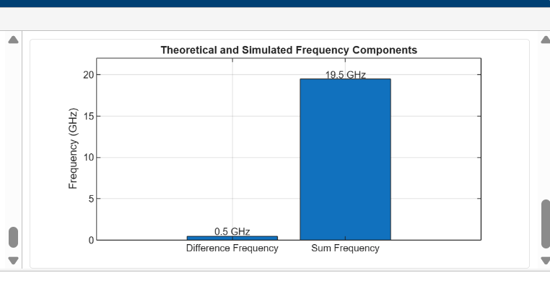
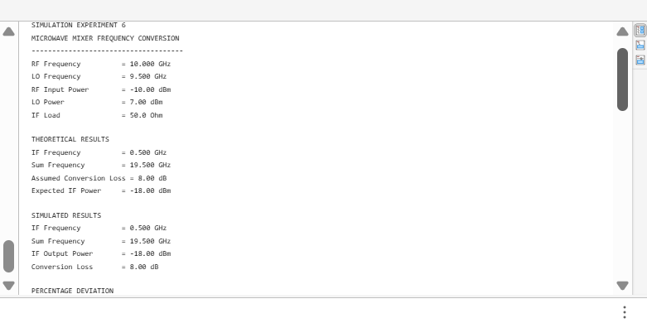
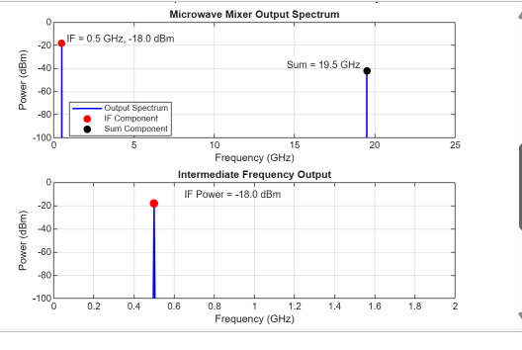
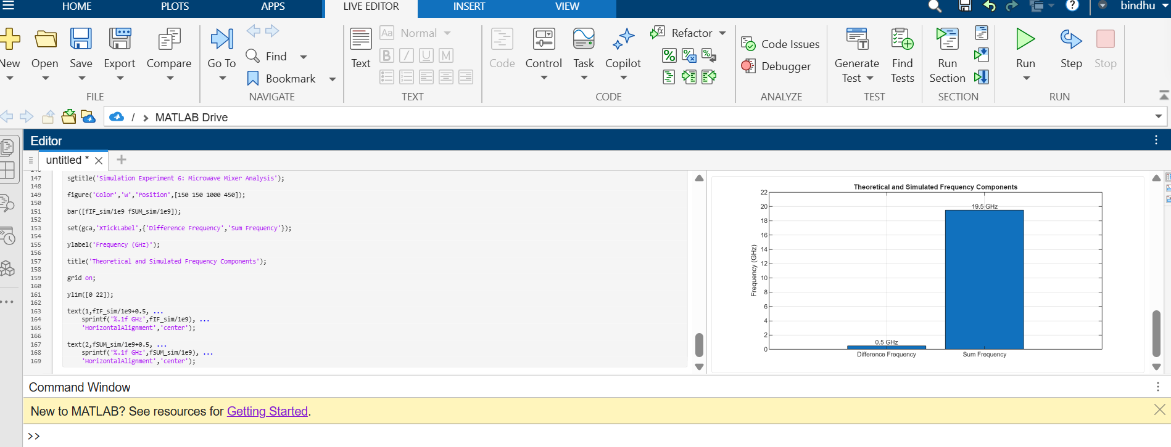
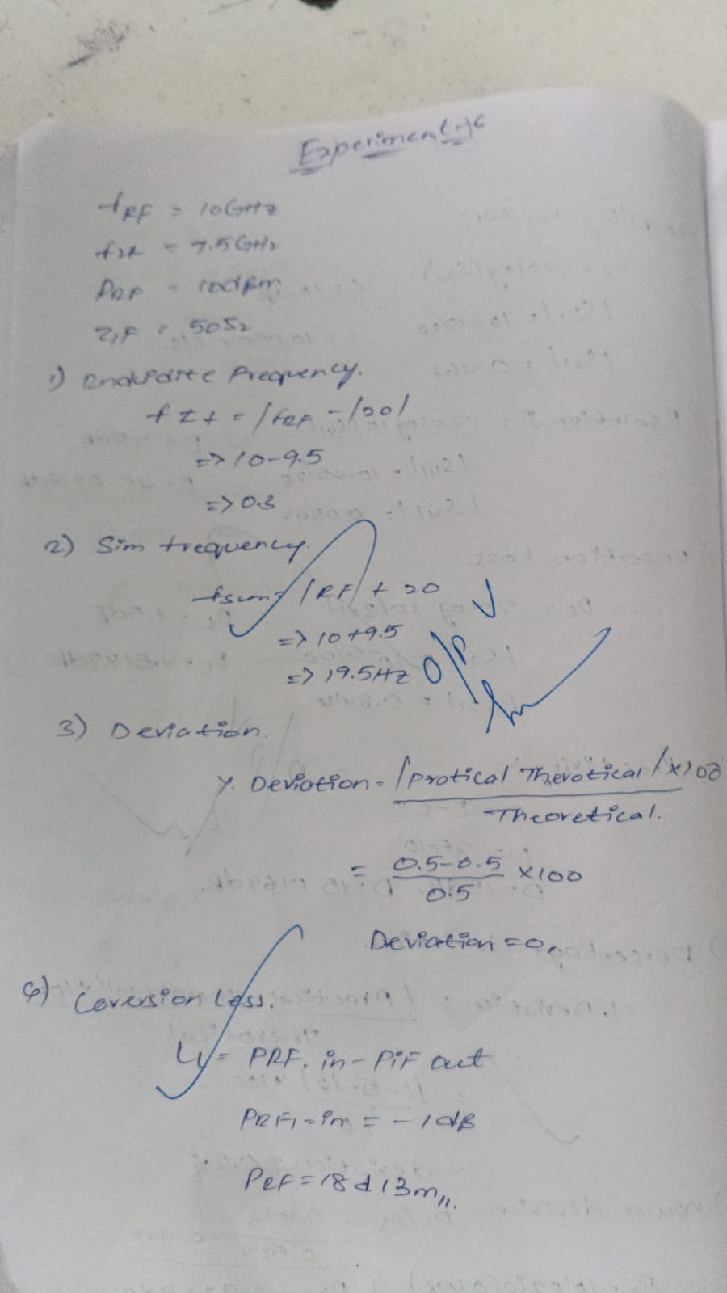

Result
The simulation demonstrated the frequency-conversion operation of a microwave mixer. The intermediate frequency was verified

